
Milestone 6 - Building on our Data Analysis
~6 hours

In this Milestone, we’ll build upon the initial data analysis that you began in Milestone 5. We’ll learn about data visualizations and other advanced data exploration techniques. This will prepare us to develop a research question and hypothesis. Let’s get into it!


Video Link

Basic Data Visualizations
Let’s continue our exploration of the data by building visualizations. Begin by watching these tutorials on the various types of visualizations that you can build in Google Sheets or Excel and the pros/cons of different chart types.
Types of charts & graphs in Google Sheets or How to build a chart in Excel

Next, explore the different kinds of charts, including why you might pick one type or another.
- Types of Visualizations: NSDC Data Science Flashcards (videos)
- Data Exploration and Visualization - COVID Case Study by Varalika Mahajan (video)
- 20 Essential Types of Graphs and When to Use Them

Mateo also built some sample charts in your data sheet (‘Milestone 4 Data’ - ‘Sample Charts’ tab). Take a look and think about what types of charts you can use to showcase some initial insights on remote work trends (Note: the second chart is only visible in Google Sheets)!

Hint: You will build some final visualizations for the Mayor’s office in Milestone 9, so don’t skip these resources!

Task 13: Experiment with Charts
Let’s practice building charts and graphs in Excel / Google Sheets using an example research question. In this Task, we’ll explore the Census Bureau’s data on disability status and geographic region.

Using the resources above, build three graphs in a new tab which relate in some way to remote work. Come back here when you’re done.

Is there a relationship between these data points? (The answer can be no, you’re experimenting here!) Do you see different relationships when you try different graph types? Write a few sentences here about what correlations you see when you try different chart types.

There found to be some consistent findings when remebering were plotted aganist Rigion, it found that the limitation in concentrating and remebering found to be consistent across the west regions and by half in the south Geographical regions. Graphs2: showcased no different results, we have recorded a similar result (6.3%) across the south regions and (12.5%) in the west. And the final plot had presented one case of hearning limitation across all the south location whereas the west demonstrated 2 and 4 Disbaility cases.

Task 14: Defining a Research Question and Building a Hypothesis
Next, draft a two sentence research question. What would you most like to know from this dataset about remote work trends? What could the data reasonably show? We aren’t going to turn to external research yet, so focus just on what this dataset could tell you.

Along with your research question, write a 2 sentence hypothesis. Given what you’ve already seen, what do you think the data will show with a bit more investigation? It’s perfectly ok to have a loose or undefined hypothesis at this stage, but try to make your research question specific.

If you’re having trouble coming up with a research question, take a look at this guide from Indiana University. Don’t be afraid to have a very specific question in mind. A general question like: “How is remote work impacting mid-sized cities?” is going to be nearly impossible to answer. You will do better if you ask a question like: “Is there a relationship between self-reported mental health / anxiety levels and working remotely for 3 or more days per week?” Another research question might be: “Are remote workers more likely to attend local museums or live entertainment venues?” You could also ask: “Do remote workers rely more on free or reduced-price internet than the average household?” These are specific questions that we can not only answer just using data from the Census Bureau, they also would be interesting to our bosses in Data Lake, who want to better understand how an influx of remote workers will impact their town. Your hypothesis is an educated guess as to what the answer of your question will be based on your preliminary research so far.

Research Question: | - Are there relationship between Disable remote workers and Remote work producitivity (Houshold income)?  -Is there a relationship between Mental Health (worry- status) and parents working from home with kids plus it’s effect in remote work?
Initial Hypothesis: | -By enabling employees to work from home, provide mobililty equipments and modified worspaces that can improve the comfort and safety of the Disable remote worker to work from home. Acknowledging that there might be many limitations in the office that stand aganist producitivity for most of the employers such as having a noisy office for ADHD Case sensitive individuals. I believe that by accomdating more disable individulas and provide more suitable policies to them the productivity in the corporate settings may increase and the ultimately the company will generate more income.  - New survey results released by child care provider Brighter Horizons revealed a remote or hybrid setting has led to extreme lonesomeness. Although the environment is flexible yet parents found difficuilties to function well while on it, this is where some more relaxed Mental health and childcare policies are required from managers. The same struggles faced by early careerest’s who are child-free parents. This Mental health effect of parents with kids that happened due to the remote work isolated environment will badely contribute to the general producitivity of an organization.

Your research question and hypothesis will guide your deep dive research in Milestone 7. From there, you’ll be able to string together key data points into insights on the state of remote work. Then, you can begin to evaluate if your hypothesis was correct and consider what your recommendations might be for the Office of the Mayor.

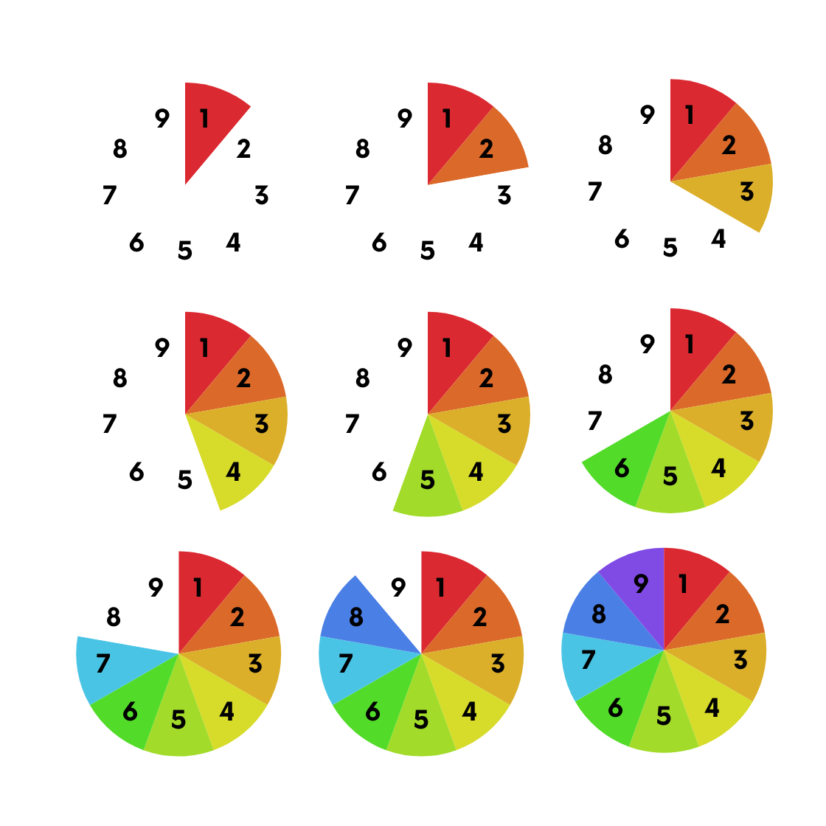
You’ve completed the 6th Milestone!

Amazing work! This Milestone is an important one which will determine how well your analysis continues in Milestone 7.

Next Steps:
We recommend taking a short break from your research so you can come back to Milestone 7 with fresh eyes. When you’re ready, come back to round off your analysis with some visualizations that will really drive your ideas home.

Milestone 7 - Testing our Hypothesis
~4 hours

In this Milestone, we’ll get deeper into your data analysis. This Milestone is very self-guided and your next steps will depend on your specific research question and hypothesis. By the end of this milestone, you will identify at least four main insights from your research which can be used to develop your two data-driven recommendations for the Mayor.


Video Link

Task 15: Developing a Research Plan & Continuing Analysis
At this stage, you’ll need to pinpoint what the next steps of your research process will be. Your research plan should include all of the steps you will need to test your hypothesis. For instance, will you need to create a few more pivot tables with multiple variables? Learn about other Excel formulas? Establish the statistical significance of your data? Explore other data sources and research for context?

Depending on the focus of your project, you may want to bring in some additional resources or data to supplement your research. For example, if you want to do more time series analyses, you could take a look at previous versions of the Household Pulse Survey. If you’re exploring the relationship between race, gender, and remote work, maybe examine some U.S. Census data. These kinds of external resources can strengthen your overall analysis, but are not required.

Don’t be afraid to go back and do some additional desk research at this stage if needed. Your analysis may reveal some new insights which require further exploration.

Outline here the basic structure of your research plan. What will you need to do next and in what order? Be as specific as possible. All the work you do here should connect in some way to the exploration of your hypothesis.

My Research Plan
To do item: | Done?
Example: Do more desk research on remote work trends for marketing careers
Example: Create a pivot table to analyze columns A-E
Example: Use new formulas to establish a relationship between Variable X and Variable Y
Conducted further research on understanding the correlation between the Parents with kids and Remote work.
Did more desk research to know the Mental health impact on Disable individuals and it is further impact on remote work.
Examine the discrete values of understandings and income
Select the Mental Health and childcare arrangments columns
Write down the observations and the findings I obtained.

Now that you have a research plan, you know what to do next. Dive deeper into the data and come back when you feel like you’ve reached some preliminary conclusions.

Hint: Don’t get stuck in your research. We recommend doing no more than 3 hours of analysis and experimentation at this point, even if it’s hard to stop!

Task 16: Identifying Research Findings
Review your research so far. What does your analysis reveal? Review this article on how to turn data into meaningful insights.

Jot down four major findings from your work below. For example, a finding might be: “Group A (which is defined by X and Y) has a vaccination rate of 20% whereas Group B (which is defined by Z) has a vaccination rate of 40%.” Most findings tie together two or more data points.
Remember that your findings should all relate back to your initial hypothesis which answers a question you had about remote work. Your findings may either support or refute your hypothesis. When possible, also try to tie your findings to a business need (in this case, something that the Mayor and her team would be interested in from either an economic, social, or political perspective, etc.). Keeping in mind the interests of your stakeholders will make it easier to pick out key findings.

Hint: As you draft your findings, remember that there is a difference between correlation and causation. Don’t automatically assume a relationship between two variables - consider if there is any other external influence at play.

Finding 1: | Remote work income increases when there is no Difficulty in understanding cases in the corporate.
Supporting Data Point 1: | This is because the coroporate usually dose not provide supporting environment for disable remote workers
Supporting Data Point 2: | Not providing supporting Porgrams and policies for Disable workers does not deduct of the overal corporate budget if dose not increase it.
Connection to initial hypothesis: | Here is a negative relationship between Disable remote workers and income.

Finding 2: | Partial difficulty of understanding Generate some income in comaprsion to alot of difficulty and can’t do at all.
Supporting Data Point 1: | Based on the assigned tasks given to the Partial difficulty status might add to the overall income
Supporting Data Point 2: | Partial difficualty might not need expensive special care in comparsion to alot and can’t do at all difficuality cases.
Connection to initial hypothesis: | The finding has presented a positive increase in the income with some limitation of understanding.

Finding 3: | Parents who are remote workers are more faced up with Mental health than their counterpart who works from the office and it is affect to the organization income.
Supporting Data Point 1: | The isolation and the kids noise increase The mental health conditions for parents that affect badly the income.
Supporting Data Point 2: | The expenses that goes for the children care program are cut of the company budget
Connection to initial hypothesis: | Remote worker Mental Health Negatively impact the company income.

Finding 4: | The Parents with kids recieve child arrangment programs which decreases the company income
Supporting Data Point 1: | The fees required for trasnportation and products needed for nuturition and child car are influencing the income
Supporting Data Point 2: | The cut off the company budget for early carrer remote workers to have empowering programs is neccessary
Connection to initial hypothesis: | Parents with kids/ Early carrer remote workers are positively impacting the income.

You’ve completed the 7th Milestone!

We’re getting there! You’ve done the difficult work of analyzing the data, now we’ll turn our attention to synthesizing that information so that others can understand and act on our conclusions. In the next Milestone, we’ll pivot from numbers to letters and begin the process of writing up our findings.

Next Steps:
We’ve reached the end of Document C. Please take a moment to complete this very short, five question Google Survey on Milestones 6 & 7. Your input here will help our team understand what resources helped you learn (or not) and what lessons you found particularly helpful.

Next up is Document D, which includes Milestones 8 & 9. We’re going to begin the process of refining our analysis and summarizing it for Mayor Ellation and her team. We’ll want to take several steps back from our in-depth research, writing and presenting our findings in an easy to understand way for our busy, multi-tasking boss!

